**Report for internship task 2:**

**Name: Shoaib Ahmed**

**Internship iD: TN/IN02/PY/027**

**Task Objective:**

The aim of this task is to show how various topics like tuples, functions, etc., are used in code."

**Code Snippets:**

1. students = ["Shoaib", "ali", "waleed", "ubaid", "abdullah"]

for student in students:

    print(student)

1. students = ["wali", "shoaib", "abdullah", "junaid", "ali"]

reversed_students = students[::-1]

print("Reversed list:", reversed_students)

Student record CRUD in dict.

4: students = {}

*def* create(*name*, *marks*):

    students[name] = marks

*def* read(*name*):

    return students.get(name, "Not found")

*def* update(*name*, *marks*):

    if name in students:

        students[name] = marks

*def* delete(*name*):

    students.pop(name, None)

create("shoaib", 90)

print(read("shoaib"))

update("shoaib", 90)

delete("shoaib")

print(read("shoaib"))  *# Should print 'Not found'*

**screenshots:**

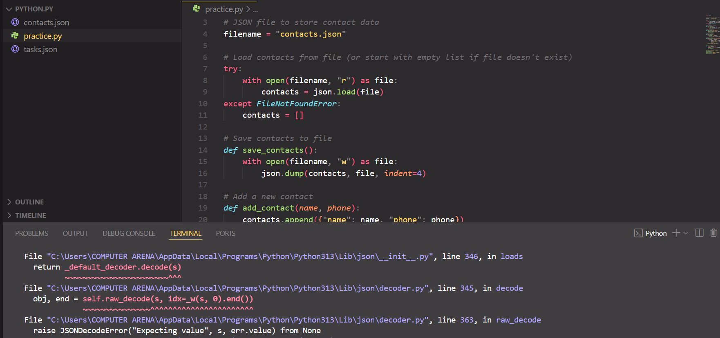

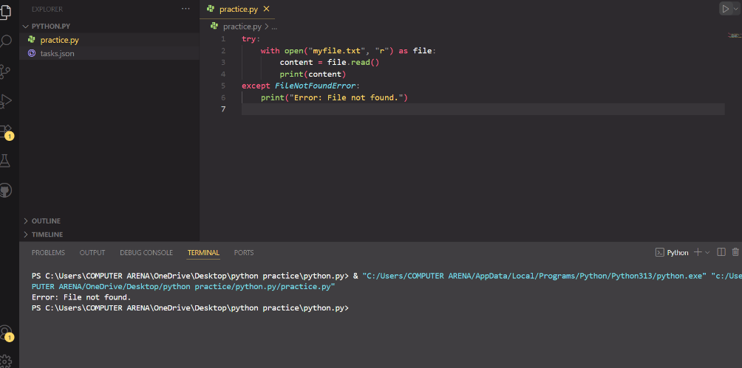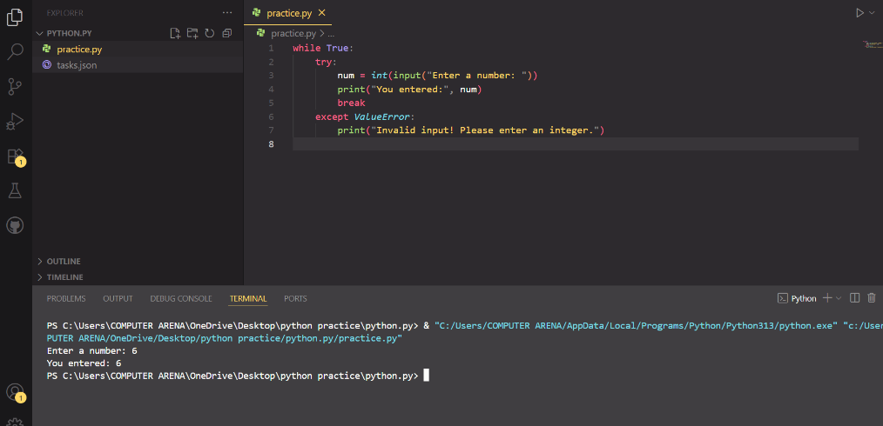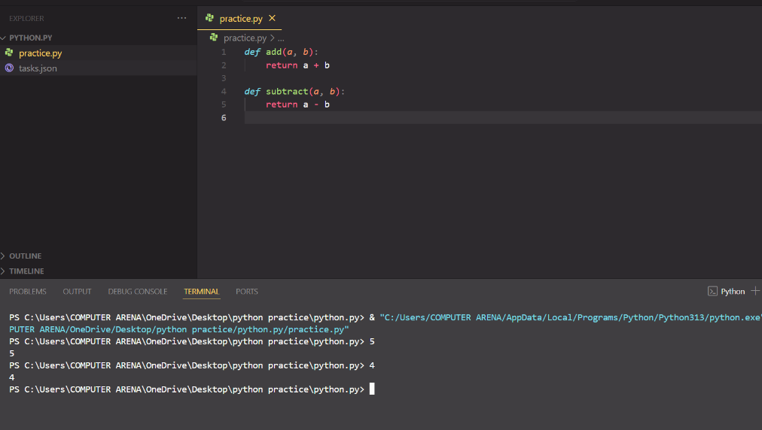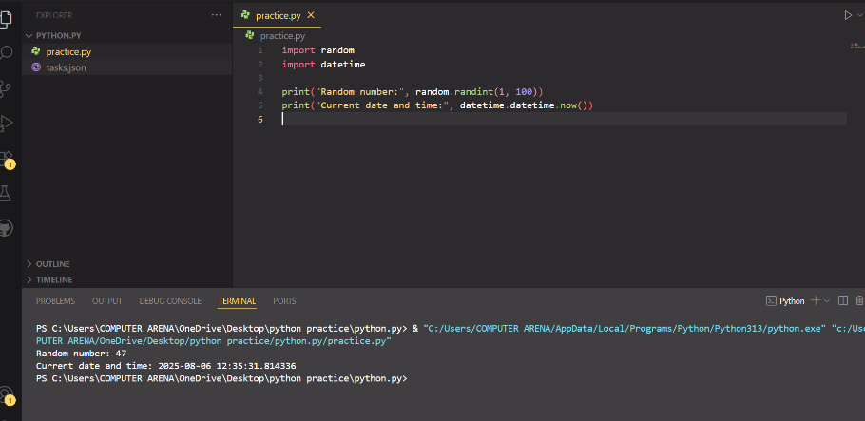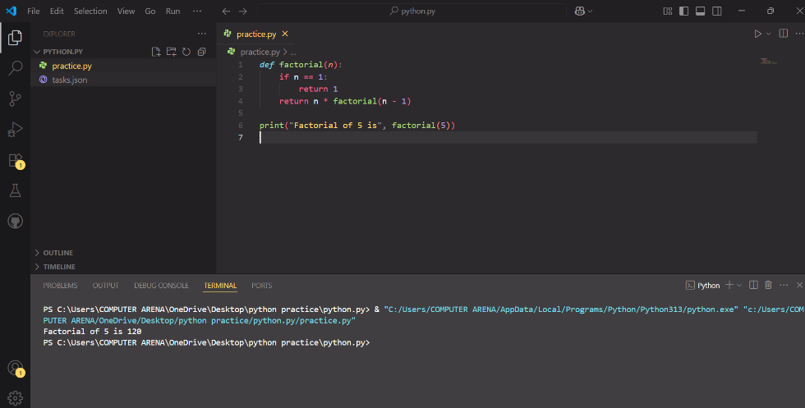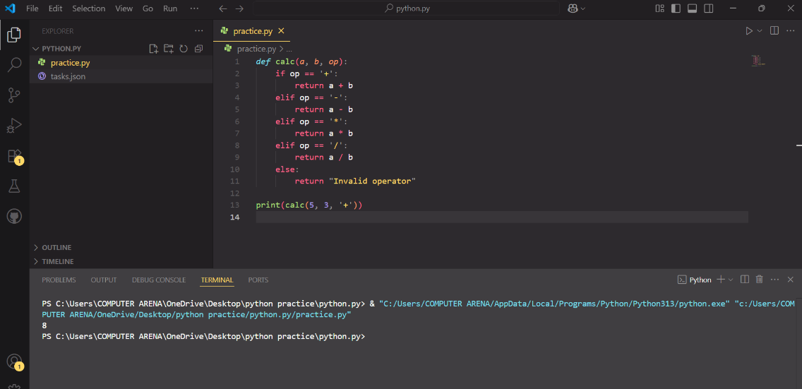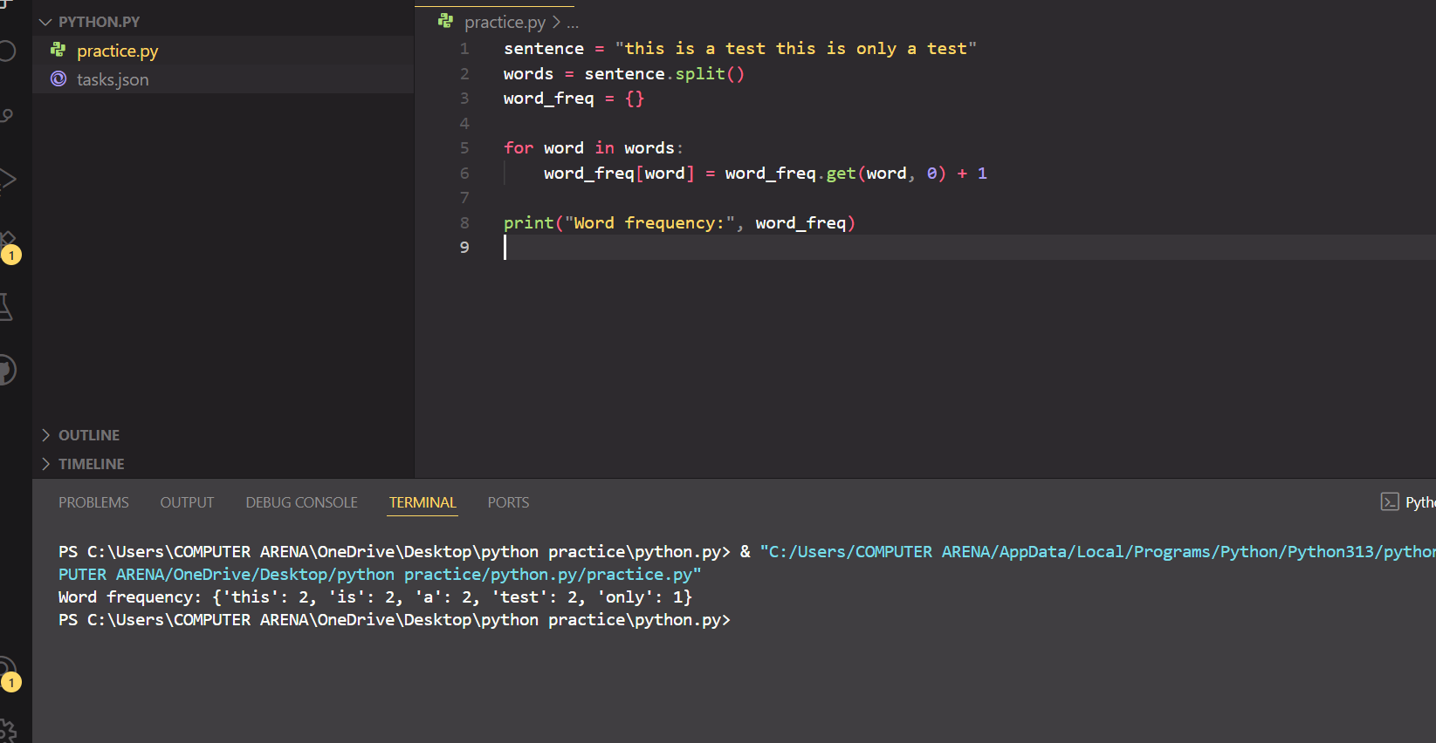

**Reflections:**

In this task, I learned about modules and dictionaries in Python. At first, I didn’t understand what a module was, but later, when I imported one file into another, I started to see how modules work. I even created my own module with some functions inside and used it in a different file. It worked well.

A dictionary is similar to a list, but it uses keys and values. I used a dictionary to store information like names and ages. In the beginning, I made a mistake by trying to access items using numbers, but then I realized that keys are needed instead. I also learned how to add new items to a dictionary and how to delete them.

Sometimes I got confused with the syntax or made spelling mistakes, but after trying several times, I was able to fix them. This task really helped me understand how to use modules and dictionaries more clearly. I feel more confident using Python now.